EXPERIMENT-7
NAME: RIYA SHARMA K ROLL NO: 240701433

AIM:
To design and compare different Hotel booking mobile app layouts using GIMP and evaluate user feedback on aesthetics and usability.

PROCEDURE:

- Installed GIMP software from the official website,But I can use in Figma
- Created a mobile screen frame ( rectangle ) .
- Designed UI layout including header, search section, and bus listing cards.
- Added UI elements such as text fields, buttons, icons, and navigation bar.
- Organized each component into separate layers for easy editing.
- Created two different layout designs with different color schemes (Light and Dark theme).
- Exported the layouts as PNG images.

LAYOUT 1 :
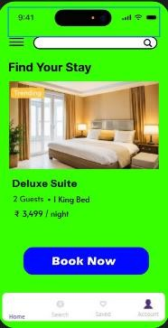

USER FEEDBACK:
https://docs.google.com/forms/d/e/1FAIpQLSflXB5SwbSmz7j7YdVhco59yghCW_DAIcMF Oge5SzKrkvg5ag/viewform?usp=dialog
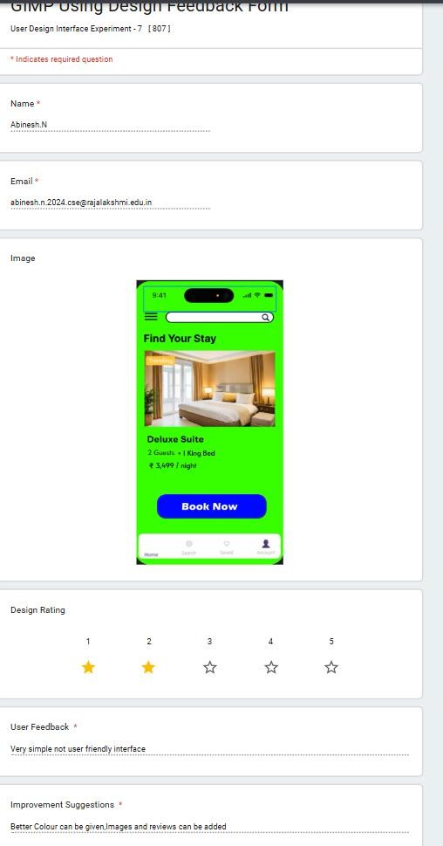
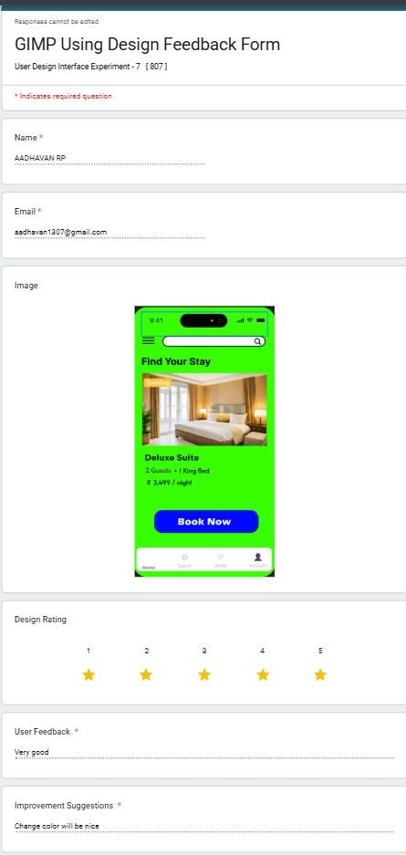

FINAL RECOMMENDATION:
Preferred Layout: Layout 2 (Light Theme User Friendly ) due to its modern appearance, better visual hierarchy, and engaging user interface.

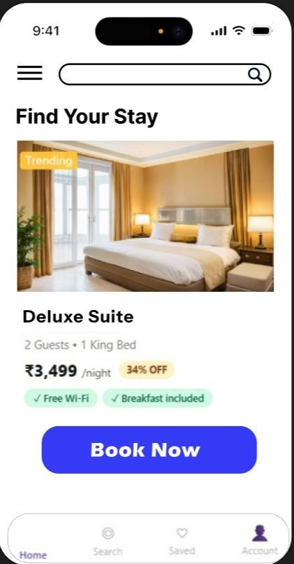

CONCLUSION:
The experiment demonstrates that visual design and color schemes significantly affect user experience. Iterating designs based on feedback helps in selecting the most effective UI layout.

